**Belo are the list of Topics I looked for in google trends and also used google search engine to find supporting information. I am choosing Topic 2 for my term project. I will be studying various types of vaccines and their effectiveness to understand which vaccine is better over another, for what reasons and what type of vaccines are being administered.**

**Topics:**

1. Diets

Paleo diet vs vegan diet vs keto diet

1. Covid Vaccine Types and Efficiency:

Pfizer vs Moderna vs Johnson Vaccines for Covid-19

1. Machine Learning vs Artificial Intelligence
2. Social advertisements

Facebook Ads vs Youtube Ads vs Instagram Ads vs Google Ads

1. Hair Straighteners

Dyson Corrale vs ghd Platinum

**Topic1: Paleo diet vs vegan diet vs keto diet**

Question: Which diet is trending?

Question: What are the content areas to consider increasing web traffic of a diet product blog?

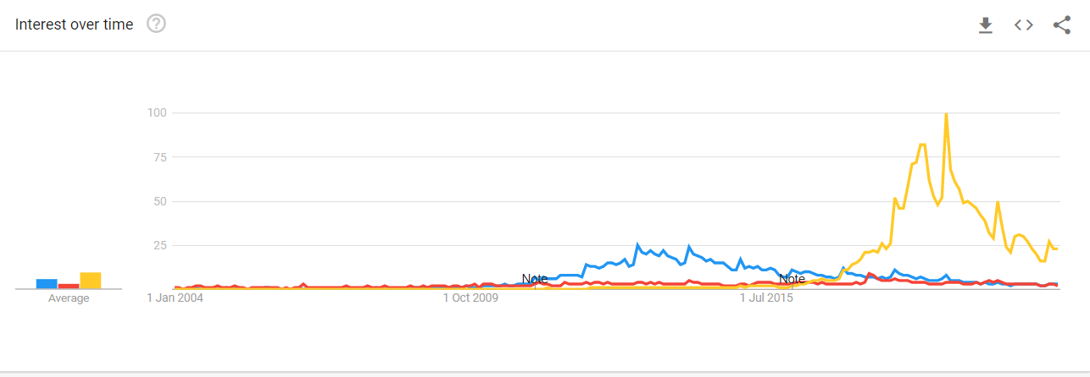

Observations:

Vegan diet was more popular until march 2010

From mid 2011, paleo diet surpassed both the diets but it was until march 2017. In 2013, paleo search went to peak that could be because evolutionary biologist Marlene Zuk's book Paleofantasy came out. [Paleofantasy | Marlene Zuk | W. W. Norton & Company](https://wwnorton.com/books/Paleofantasy/)

From March 2017, keto diet is the most search diet and it continue to do so.

A recent market study by Mordor Intelligence, titled “Ketogenic Diet Food Market – Growth, Trends, And Forecast (2019 – 2024),” finds that, on a global level, the ketogenic diet food market is projected to grow at a compound annual growth rate of 5.3 percent. The report bases its findings on the rising demand for Keto-friendly food options at restaurants and eateries. [Ketogenic Diet Food Market – Growth | Trends | Forecast (2021 - 2026) (mordorintelligence.com)](https://www.mordorintelligence.com/industry-reports/ketogenic-diet-food-market)

Another study quantified the expected market growth of the Keto Diet and estimates that it could grow from US $9.6 billion in 2018 US $15.6 billion by 2027. The anticipated growth of the Keto Diet market obviously opens opportunities for thousands of smaller Keto and low carb food brands to establish a growing business. [Ketogenic Diet Market Forecast to 2027 - COVID-19 Impact and Global Analysis by Product Type (Supplements, Beverages, Snacks, Dairy, and Others); and Distribution Channel (Hypermarket & Supermarket, Specialty Stores, Convenience Stores, and Others); and Geography (researchandmarkets.com)](https://www.researchandmarkets.com/reports/4825239/ketogenic-diet-market-forecast-to-2027-covid-19?utm_source=CI&utm_medium=PressRelease&utm_code=wpcptk&utm_campaign=1287392+-+%2415.6+Billion+Ketogenic+Diet+Market+-+Global+Analysis+and+Forecasts+to+2027&utm_exec=chdo54prd)

Rise of Overweight and Obesity: New data shows that the obesity has reached epidemic proportions since the turn of the century. Estimates suggest that more than 75% of the US population is overweight, and that the obesity rate is more than 40%. Because the Keto diet has clinical evidence for reducing weight and body-fat percentage more rapidly than other diets in obese and diabetic consumers, the growth in the prevalence of overweight and obesity will likely be a key driver in the growth of the keto market during the forecast period.

So from these observations, can agree that keto diet is most trending diet.

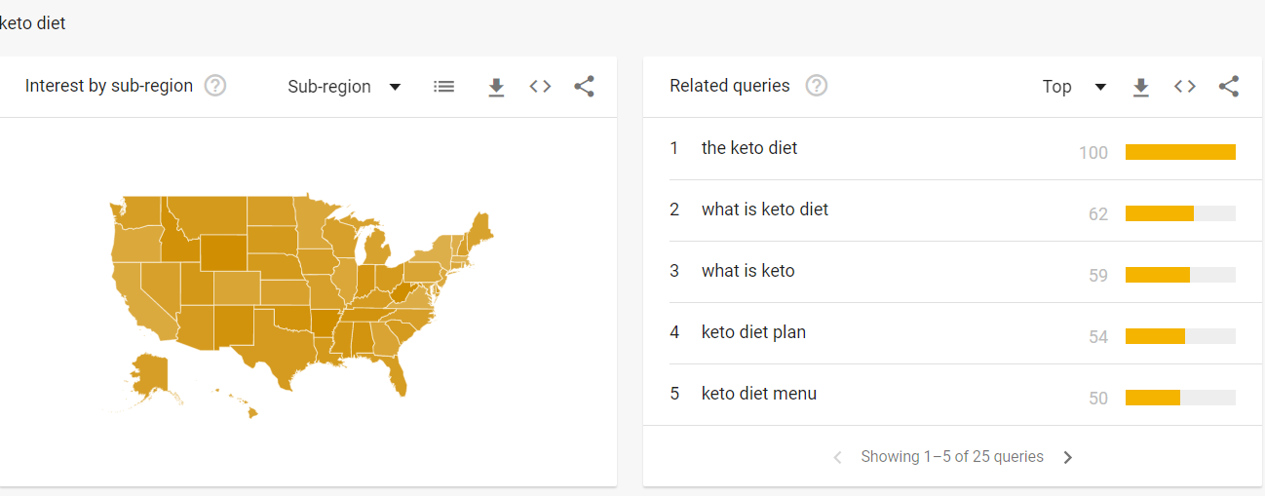

Top queries are around what is keto diet, diet plan and diet menu. So with these results, creating content to explain keto diet and creating customized diet plans and recipes would increase the web traffic to the blog.

**Topic2: moderna vaccine vs Pfizer vaccine vs johnson & Johnson vaccine**

Question: Which one is popular?

Question: Which states are leaning to what vaccine?

Question: Which Vaccine is effective?

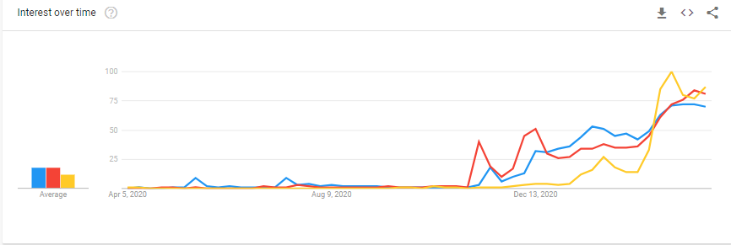

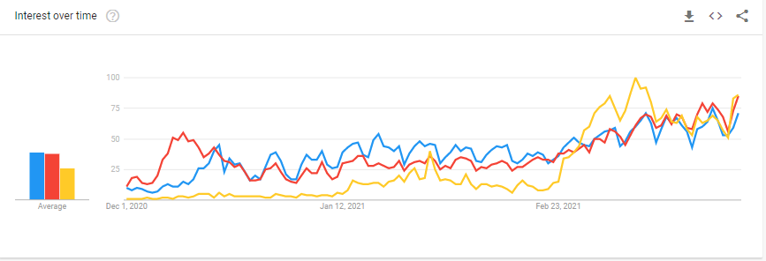

Observations:

Starting Nov,2020, the search on covid vaccines have started and its grown exponentially. That’s because federal government have started to distribute the doses to the states.

Pfizer was in lead and until mid December 2020 then after moderna popularity increased until johnson took over on Feb 27th 2021. This could be because on Feb 27th, FDA has issued Emergency Use Authorization (EUA) for its single-dose COVID-19 vaccine, developed by the Janssen Pharmaceutical Companies of Johnson & Johnson, to prevent COVID-19 in individuals 18 years of age and older. <https://www.jnj.com/johnson-johnson-covid-19-vaccine-authorized-by-u-s-fda-for-emergency-usefirst-single-shot-vaccine-in-fight-against-global-pandemic>

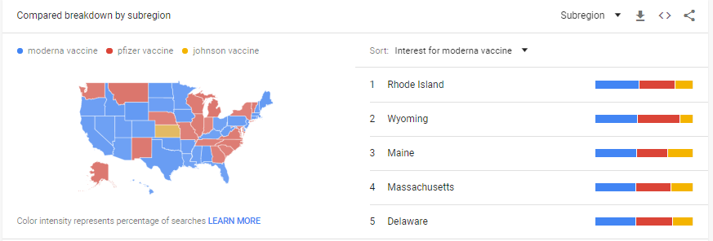

Most of the states searched for moderna over Pfizer or johnson may be because Pfizer vaccine requires to be stored in ulta cold temperature where as moderna can be stored at little below normal temperature and suitable for small and rural sites. Surprisingly Johnson and Johnson was searched only Kansas state that’s may be because of the news that vaccines thrown out due to transfer error or could be related johnson county in Kansas state.

As per the statenews, [Comparing three Covid-19 vaccines: Pfizer, Moderna, J&J (statnews.com)](https://www.statnews.com/2021/02/02/comparing-the-covid-19-vaccines-developed-by-pfizer-moderna-and-johnson-johnson/), The Pfizer vaccine showed efficacy of 95% at preventing symptomatic Covid infection after two doses. The vaccine appeared to be more or less equally protective across age groups and racial and ethnic groups. Minimum amount of vaccine a location can order is 1170 doses.

The Moderna vaccine was 94.1% effective at preventing symptomatic Covid-19 after the second dose. Minimum amount of vaccine a location can order is 140 doses.

The Johnson vaccine was 72% protective in the United States.

Based on the above preliminary analysis, Pfizer vaccine has better efficiency, but states leaned to Moderna due to ease of storage conditions and also minimum purchase order requirement.

**Topic3: Machine Learning vs Artificial Intelligence**

Question: Which is popular in US and in which states?

Observations:

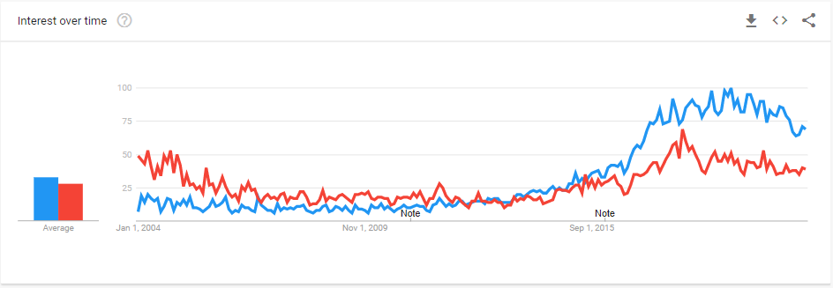

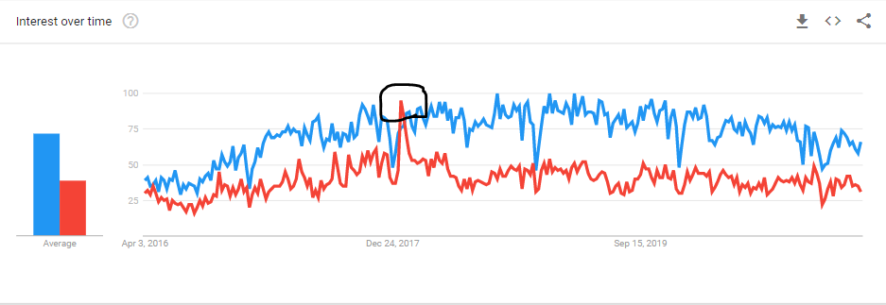

Artificial Intelligence (AI) is not a new concept. It was very hot in 2004.

Machine Learning (ML) surpassed AI in Q3 2015, and has since then searched more than AI

In Dec. 2017, there was a spike in AI. It is possibly related to big news and controversial remarks made by technology leaders. Russia predicted whichever country takes the lead in AI research and development will eventually rule the world. Tesla CEO Elon Musk, renowned for his dystopian stance on AI, called for proactive regulation against unleashing AI that could potentially pose an existential threat to humanity.

The states that ML is searched more than AI are the states that have more tech companies. The three states that has the highest ML-to-AI ratio are Washington, Massachusetts and California.

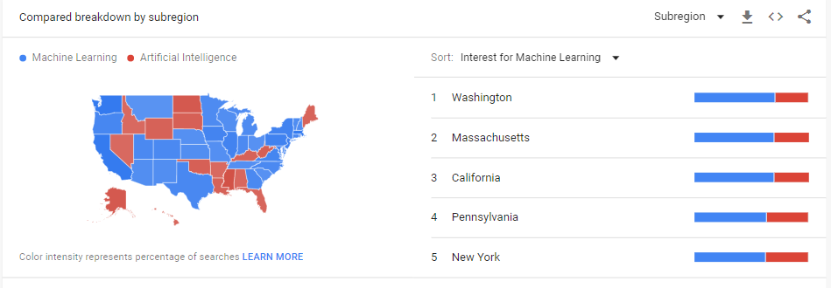

**Topic4: Facebook Ads vs Youtube Ads vs Instagram Ads vs Google Ads**

Question: Which are better for good potential customer reach?

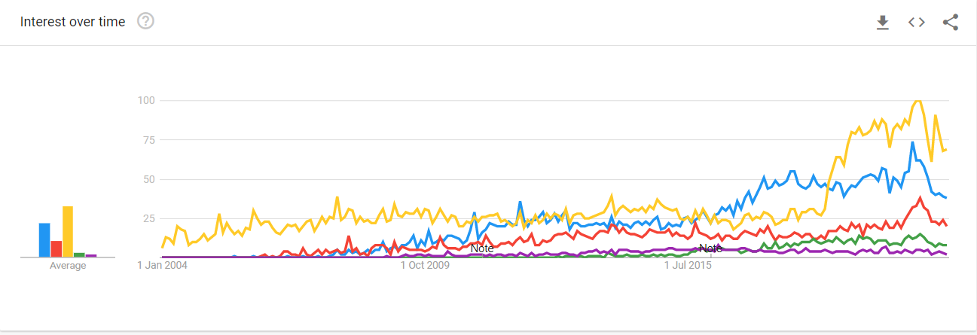

Google Ads is popular from 2004 and is trending upward

Facebook and Youtube started around same time but Facebook surpassed youtube ads

From Mid 2016 to Mid 2018, facebook surpassed google ads too. This could be due to facebook ad campaign to US elections.

So based on the preliminary analysis, it is narrowed down to Facebook or google. Facebook has targeting advantage as it has wealth of data and knows an impressive amount about its users—life events, interests, behaviors, and more. Facebook’s targeting capabilities won’t help you if you don’t know who to target. Google Ads primarily target the keywords people type into Google’s search engine, so you don’t need to know exactly who your audience is to get your ads in front of interested prospects.

So based on further research, facebook ads are better if you know who to target and google ads are better if you are not sure who your audience is so based on the requirement, either one of it can be leveraged.

**Topic6: Dyson Corrale vs ghd Platinum**

Question: Which straightener is better?

Questions:

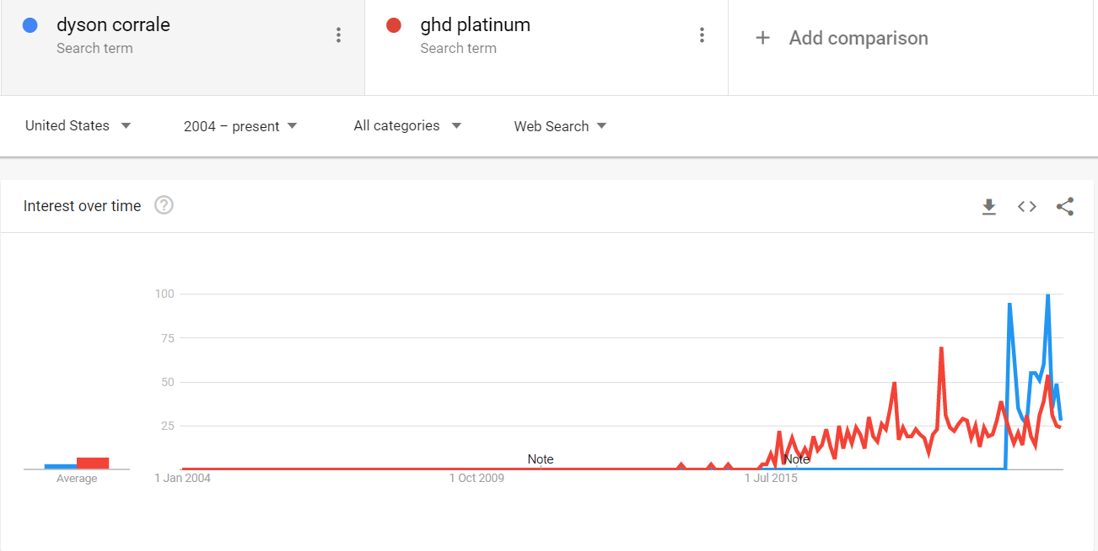

Observations:

1. ghd platinum was leading model until march 2020. On March 10th dyson announced its launch of straightner.

Dyson stepped into the hair industry back in 2016 with the launch of its groundbreaking Dyson Supersonic hairdryer and after being swept away by both the dryer and the more recent Dyson Airwrap, beauty fans have been eagerly awaiting the brand entering the straighteners game.

Corrale has 3 different heat settings. Corral measures the heat of the plates 100 times a second, giving it an even heat and ensuring there are no spots on the straightener getting warmer than the others. Due to its higher heat range settings, Dyson Corrale is expensive.

Frizzier or dry and damaged hair types will benefit more from the Corrale, as it straightens in just one swipe and reduces damage with the way it functions. It’s also the clear choice for anyone who wants a proper multitasking tool, as curls and waves definitely come out better than with the Platinum+ and last longer without falling out. But its super pricy.

However, if you don’t have the cash to splash, the GHD Platinum+ is still far superior to any other straightener on the market. It’s the clear winner if you’re looking for something that adds class to your dressing table, and will more than do the job for those with fine hair or who don’t reach for the heat tools that often. If you’re upgrading from any other styler you’ll find using the Platinum+ a treat.

Even thought Corrale has quite a few good benefits but the data is volatile, so it is difficult to make any conclusion alone with this data.